Assignment – 2
20MCMB15-IT
Sachin Y. Sah
Q.1 Build a Technical Documentation Page.

Index.html

<!DOCTYPE html>
<html lang="en">
<head>
<meta charset="utf-8">
<meta name="viewport" content="width=device-width, initial-scale=1">
<title>Technical Documentation | 20MCMB15</title>
</head>
<body>
<link rel="stylesheet" href="main.css">
<!-- Div tag is block level tag and generic container tag. It is used to the group of various tags so that sections can be created and style can be applied to them. -->
<!-- i have used bootstrap. container-fluid class provides full width container, spanning the entire width of the viewport -->
<div class="container-fluid">
<!-- bootstrap used row class is used for making grid layout-->
<div class="row">
<!-- md stands for small laptop, sm for tablets, xs for phones -->
<div class="col-md-10 col-sm-12 col-xs-12 col-xs-12">
<nav id="navbar">
<header>Android Documentation</header>
<ul class="nav nav-pills nav-stacked">
<a class="nav-link" href="#overview" rel="internal">
<li>Overview</li>
</a>
<a class="nav-link" href="#environment" rel="internal">
<li>Android - Environment Setup</li>
</a>
<a class="nav-link" href="#architecture" rel="internal">
<li>Android - Architecture</li>
</a>
<a class="nav-link" href="#components" rel="internal">
<li>Android - Application Components</li>
</a>
<a class="nav-link" href="#helloworld" rel="internal">
<li>Android - Hello World Example</li>
</a>
<a class="nav-link" href="#qna" rel="internal">
<li>Android Questions and Answers</li>
</a>
<a class="nav-link" href="#Reference" rel="internal">
<li>Reference</li>
</a>
</ul>

</nav>
</div>

<div class="col-md-10 col-sm-12 col-xs-12">
<main id="main-doc">
<section class="main-section" id="overview">
<header>Overview</header>
<!-- The <article> tag specifies independent, self-contained content. -->
<article>
<center>
<img src="android.jpg">
</center>

<p>Android is an open source and Linux-based Operating System for mobile devices such as smartphones and tablet computers. Android was developed by the Open Handset Alliance, led by Google, and other companies.</p>

<p>Android offers a unified approach to application development for mobile devices which means developers need only develop for Android, and their applications should be able to run on different devices powered by Android.</p>

<p>The first beta version of the Android Software Development Kit (SDK) was released by Google in 2007 where as the first commercial version, Android 1.0, was released in September 2008.</p>

<p>On June 27, 2012, at the Google I/O conference, Google announced the next Android version, 4.1 Jelly Bean. Jelly Bean is an incremental update, with the primary aim of improving the user interface, both in terms of functionality and performance.<br>

The source code for Android is available under free and open source software licenses. Google publishes most of the code under the Apache License version 2.0 and the rest, Linux kernel changes, under the GNU General Public License version 2.</p><br>

</artice>
</section>
<section class="main-section" id="environment">
<header>Android - Environment Setup</header>
<article>
<p>You will be glad to know that you can start your Android application development on either of the following operating systems − </p>

<li>Microsoft Windows XP or later version.</li>
<li>Mac OS X 10.5.8 or later version with Intel chip.</li>
<li>Linux including GNU C Library 2.7 or later.</li>

<p>Second point is that all the required tools to develop Android applications are freely available and can be downloaded from the Web. Following is the list of software's you will need before you start your Android application programming. </p>

<li>Java JDK5 or later version</li>
<li>Mac OS X 10.5.8 or later version with Intel chip.</li>
<li>Android Studio </li>

<p>Here last two components are optional and if you are working on Windows machine then these components make your life easy while doing Java based application development. So let us have a look how to proceed to set required environment.</p>

<p>You can download the latest version of Java JDK from Oracle's Java site − Java SE Downloads. You will find instructions for installing JDK in downloaded files, follow the given instructions to install and configure the setup. Finally set PATH and JAVA_HOME environment variables to refer to the directory that contains java and javac, typically java_install_dir/bin and java_install_dir respectively.<br>
If you are running Windows and installed the JDK in C:\jdk1.8.0_102, you would have to put the following line in your C:\autoexec.bat file.</p>

<!-- The <code> tag is used to define a piece of computer code and it will differentiate from -->
<code>
set PATH=C:\jdk1.8.0_102\bin;%PATH%
set JAVA_HOME=C:\jdk1.8.0_102
</code>

</artice>
</section>
<section class="main-section" id="architecture">
<header>Android - Architecture</header>
<article>
<p>Android operating system is a stack of software components which is roughly divided into five sections and four main layers as shown below in the architecture diagram.</p>

<center>
<img src="architecture.jpg">
</center>
<p><h3>Libraries</h3>

On top of Linux kernel there is a set of libraries including open-source Web browser engine WebKit, well known library libc, SQLite database which is a useful repository for storage and sharing of application data, libraries to play and record audio and video, SSL libraries responsible for Internet security etc.</p>

<p><h3>Linux kernel</h3>

At the bottom of the layers is Linux - Linux 3.6 with approximately 115 patches. This provides a level of abstraction between the device hardware and it contains all the essential hardware drivers like camera, keypad, display etc. Also, the kernel handles all the things that Linux is really good at such as networking and a vast array of device drivers, which take the pain out of interfacing to peripheral hardware.</p>
</article>
</section>
<section class="main-section" id="components">
<header>Android - Application Components</header>
<article>
Application components are the essential building blocks of an Android application. These components are loosely coupled by the application manifest file AndroidManifest.xml that describes each component of the application and how they interact.

<h3>Activities</h3>

An activity represents a single screen with a user interface,in-short Activity performs actions on the screen. For example, an email application might have one activity that shows a list of new emails, another activity to compose an email, and another activity for reading emails. If an application has more than one activity, then one of them should be marked as the activity that is presented when the application is launched.
Select the code in the pad and hit Ctrl+R to watch it unfold in your browser!

<p>An activity is implemented as a subclass of Activity class as follows − </p>
<code>
public class MainActivity extends Activity {}
</code>

<h3>Services</h3>

A service is a component that runs in the background to perform long-running operations. For example, a service might play music in the background while the user is in a different application, or it might fetch data over the network without blocking user interaction with an activity.

<p>A service is implemented as a subclass of Service class as follows −</p>
<code>
public class MyService extends Service {}
</code><br>
</article>
</section>

<section class="main-section" id="helloworld">
<header>Android - Hello World Example</header>
<article>
<p>
Let us start actual programming with Android Framework. Before you start writing your first example using Android SDK, you have to make sure that you have set-up your Android development environment properly as explained in Android - Environment Set-up tutorial. I also assume that you have a little bit working knowledge with Android studio.
</p>
<p>So let us proceed to write a simple Android Application which will print "Hello World!".
</p>
<p>
You can use ISO 8859-1 or Unicode letters such as å and ü in identifiers. You can also use the
Unicode
escape sequences as characters in identifiers.

Some examples of legal names are Number_hits, temp99, and _name.
</p>

<h3>The Main Activity File</h3>

The main activity code is a Java file MainActivity.java. This is the actual application file which ultimately gets converted to a Dalvik executable and runs your application. Following is the default code generated by the application wizard for Hello World! application −

<code>
package com.example.helloworld;

import android.support.v7.app.AppCompatActivity;
import android.os.Bundle;

public class MainActivity extends AppCompatActivity {
@Override
protected void onCreate(Bundle savedInstanceState) {
super.onCreate(savedInstanceState);
setContentView(R.layout.activity_main);
}
}
</code><br>

<p>Here, R.layout.activity_main refers to the activity_main.xml file located in the res/layout folder. The onCreate() method is one of many methods that are figured when an activity is loaded.</p>

</article>
</section>

<section class="main-section" id="qna">
<header>Android Questions and Answers</header>
<article>
<p>
Android Questions and Answers has been designed with a special intention of helping students and professionals preparing for various Certification Exams and Job Interviews. This section provides a useful collection of sample Interview Questions and Multiple Choice Questions (MCQs) and their answers with appropriate explanations.
</p>
<ol>
<li>
<h3>Android Interview Questions</h3>
<p>
This section provides a huge collection of Android Interview Questions with their answers hidden in a box to challenge you to have a go at them before discovering the correct answer.
</p>
<li>
<h3>Android Online Quiz</h3>
<p>
This section provides a great collection of Android Multiple Choice Questions (MCQs) on a single page along with their correct answers and explanation. If you select the right option, it turns green; else red.
</p>
<li>
<h3>Android Mock Test</h3>
<p>
This section provides various mock tests that you can download at your local machine and solve offline. Every mock test is supplied with a mock test key to let you verify the final score and grade yourself.
</p>
</ol>

<p>Android is an open source and Linux-based operating system for mobile devices such as smartphones and tablet computers. Android was developed by the Open Handset Alliance, led by Google, and other companies. This tutorial will teach you basic Android programming and will also take you through some advance concepts related to Android application development.</p><br><br><br><br>

</article>
</section>

<section class="main-section" id="Reference">
<header>Reference</header>
<article>
<li><a href="https://www.tutorialspoint.com/android/">Android toturials</a>
</article>
</section>
</main>
</div>
</div>
</div>
</body>
</html>

main.css

html,body{

color: #f7f7f7;
background-color: #f7f7f7;
line-height: 1.5;
}

/* setting style for left-side navigation bar */
#navbar{
position:fixed;
top:0px;
left:0px;
width:250px;
height:100%;
border-right:solid;
border-color:black;
}

header{
text-align:center;
font-weight: bold;
font-size: 1.6em;
background-color:#028de3;
color: white;
padding-left: 15px;
}

/* setting hover means when we are taking curson on the list it will show black */
a li:hover {
background-color: black!important;
color:white!important;
}

/* styling the header present in the main document page */
#main-doc header{
text-align:left;
margin-top: 10px;
margin-left:80px;
}

/* for the ul(unordered list) tag item in the left-side navigation */
#navbar ul{
height:88%;
overflow-y:auto;
overflow-x:hidden;
}

/* for the li(list item) tag item in the left-side navigation */
#navbar li{
color: #3f4547;
padding:8px;
list-style: none;
position:relative;
width:100%;
}

/* setting style for main page where all the topic are explained */
#main-doc{
position: absolute;
margin-left:150px;
margin-top: 10px;
padding:20px;
margin-bottom:110px;
}

/* article tag present in the section tag */
section article{
height: 100%;
color: #3f4547;
margin:15px;
font-size:1em;
margin-left: 100px;
}

/* li tag present in the section tag */
section li {
margin:15px 0px 0px 20px;
}

/* for the code tag */
code{
display:block;
text-align: left;
white-space: pre;
position: relative;
word-break: normal;
word-wrap: normal;
line-height: 1;
background-color: white;
padding:15px;
margin:10px;
border-radius:5px;
}

OUTPUT :

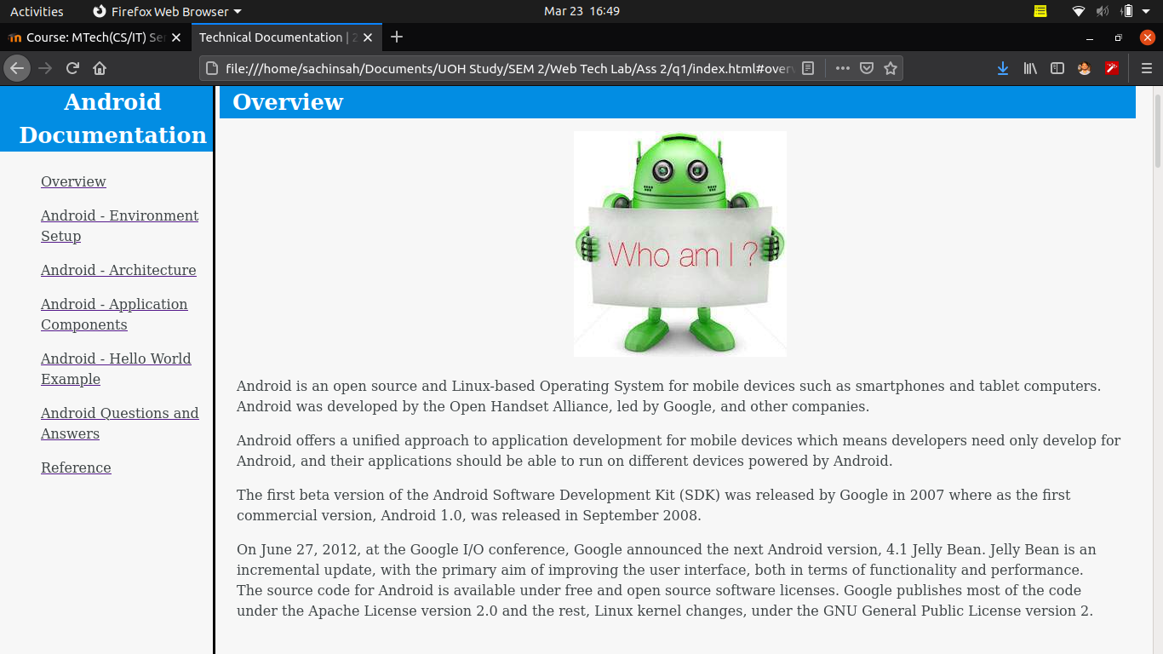
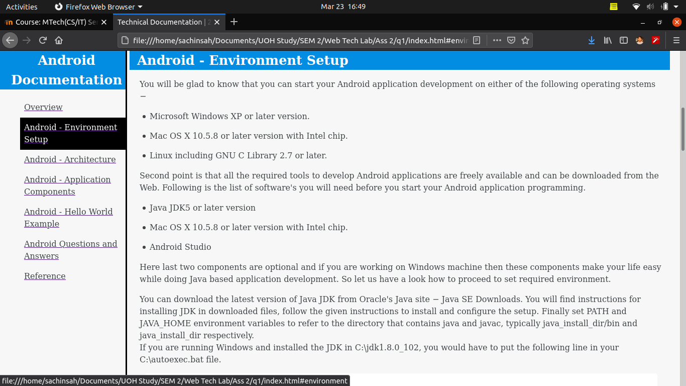

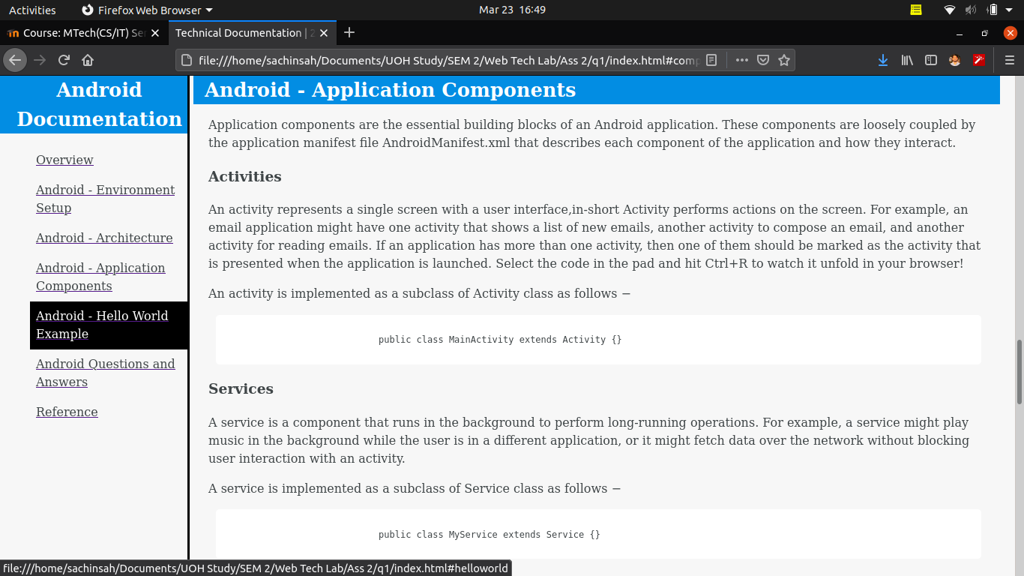
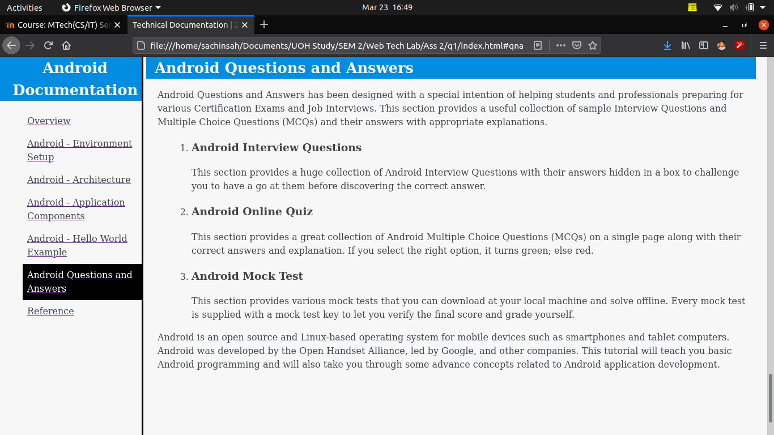

Q.2 Build a Personal Portfolio page.

Index.html

<!DOCTYPE html>
<html lang="en">
<head>
<meta charset="utf-8">
<meta name="viewport" content="width=device-width, initial-scale=1">
<style type="text/css">
/* width and height is set to max because of iframe if it is not set then iframe size is set default and we cannot use all the area of the page efficiently */
/* text font and size is set */
html,body{
width: 100%;
height: 100%;
font-family:"Raleway",Helvetica,sans-serif;
font-size: 20px;
}

/* border width is set to 2px and its color to red */
iframe{
border: 2px solid red;
}

</style>
<title>Profile | 20MCMB15</title>
</head>
<!-- background color of body is set-->
<body bgcolor="#4dc3ff">

<!-- src attribute is used for the page you want to load in iframe and name attribute to access that iframe and can be used futher -->
<iframe src="name.html" width="100%"></iframe>
<iframe src="menu.html" width="20%" height="68%"></iframe>
<iframe name="main_frame" width="59%" height="68%"></iframe>
<iframe src="image.html" width="18%" height="68%"></iframe>

<!-- &nbsp; is used for providing space-->
<center> Contact : 7802008521 &nbsp;&nbsp;&nbsp;&nbsp;&nbsp;&nbsp;&nbsp;&nbsp;&nbsp;&nbsp; Email : ssk1222014@gmail.com </center>

</body>
</html>

menu.html

<!DOCTYPE html>
<html>
<head>
<title>Menu | 20MCMB15</title>
<style type="text/css">

/* text within a tag font is set and its size */
a{
font-family:"Raleway",Helvetica,sans-serif;
font-size: 20px;
}

/* a tag default link color is set to black */
a:link{
color: black;
}

/* link when visited then its color is set to blue */
a:visited{
color: blue;
}

/* link which is active its color is set to red */
a:active{
color: red;
}
</style>
</head>
<body>

<!-- a tag is used to add link to some text and target attribute is used for whne link is click where to show the page -->
<a href="desc.html#objective" target="main_frame"> Objective </a><br><br><br>
<a href="desc.html#pinfo" target="main_frame"> Personal Information </a><br><br><br>
<a href="desc.html#finfo" target="main_frame"> Family Information </a><br><br><br>
<a href="desc.html#eduinfo" target="main_frame"> Educational Information </a><br><br><br>
<a href="desc.html#experience" target="main_frame"> Experience </a><br><br><br>
<a href="desc.html#achievements" target="main_frame"> Achievements </a><br><br><br>
<a href="desc.html#other" target="main_frame"> Others </a>

</body>
</html>

desc.html

<!DOCTYPE html>
<html>
<head>
<title>Description</title>

<style type="text/css">
/* height of the section is set to 100 because we have used section in the internal link so only one section should show in one page */
section{
height: 100vh;
}
/* text font is changes and text size is set */
h1{
font-family:"Raleway",Helvetica,sans-serif;
font-size: 35px;
margin: 0;
}
/* text font is changes and text size is set */
body{
font-family:"Raleway",Helvetica,sans-serif;
font-size: 20px;
}
</style>
</head>
<body>

<label ></label>
<!-- we have divide the page into different section so that appropriate data is called when clicked on hyderlink described -->
<section id="objective">
<!-- center is used to set thing in the center of the page -->
<br><br><center> <h1>Objective</h1> </center>
To work in a firm with a professional work in driven environment where I can utilize and apply my knowledge, skills which would enable me to grow while fulfilling organizational goals.
</section>

<section id="pinfo">
<br><br><center> <h1>Personal Information</h1> </center>
I am Sachin Sah and am from surat, Gujarat. I have done diploma in computer engineering after 10th from R.C. Technical Institute, Ahmedabad. I have completed by BE in Computer Science from Maharaja Sayajirao university of baroda. I am currently pursuing Mtech in Information Technology from University of Hyderabad.
</section>

<section id="finfo">
<br><br><center> <h1>Family Information</h1> </center>
My father is supervisor in mechanical company and my mom is a housewife.
</section>

<section id="eduinfo">
<br><center> <h1>Educational Information</h1> </center><br><br>
Master of Technology (Information technology)<br>
University of Hyderabad<br>
Hyderabad, India<br>
<br>
Bachelor of Engineering (Computer Science)<br>
Maharaja Sayajirao University<br>
Vadodara, India<br>
<br>
Diploma in Computer Engineering<br>
Gujarat Technical University<br>
Ahmedabad, India<br>
<br>
High School<br>
Gujarat Secondary And Higher Secondary<br>
Education Board<br>
Surat, India<br>

</section>

<br>
<br><br>
<section id="experience">
<br><br><center> <h1>Experience</h1> </center><br><br>
System Engineer<br>
Axelor Technologies India Pvt. Ltd.<br>
05/2019 - 03/2020,<br>
Surat, India<br><br>
Achievements/Tasks<br>
Worked on Axelor Open Suite (ERP) application and also
client projects based on ERP software modifications.<br>
Expanded Knowledge in Java | Hibernate | PostgreSQL |
RestAPI | Guice | Gradle | Git.
</section>

<section id="achievements">
<br><br><center> <h1>Achievements</h1> </center><br><br>
- Represented college in cricket<br>
- Executive member of the Event Organizing
Committee in Diploma College.
</section>

<section id="other">
<br><br><center> <h1>Other</h1> </center><br><br>
<center>LANGUAGES KNOWN</center><br>
English<br>
Professional Working Proficiency <br>
Hindi<br>
Full Professional Proficiency<br>
Gujarati<br>
Full Professional Proficiency<br>
Bihari<br>
Full Professional Proficiency<br>

<br><br>
<center>HOBBIES</center><br>
bodybuilding<br>
playing a musical instruments<br>
Playing Games<br>
Cooking
</section>

</body>
</html>

image.html

<!DOCTYPE html>
<html>
<head>
<title>image</title>
</head>
<body>
<!-- img tag is used to add image in the page and here margin-top is used to mark where to start -->
<img src="happy.svg" style="margin-top: 100px;" >
</body>
</html>

name.html

<!DOCTYPE html>
<html>
<head>
<title>Sachin Sah | 20MCMB15</title>
</head>
<style type="text/css">

/* image to set to left and left margin is set */
img{
float: left;
margin-left: 5px;
}

/* text font is changes and text size is set */
h1{

font-family:"Raleway",Helvetica,sans-serif;
font-size: 60px;
margin: 10px;
}

</style>
<body>

<img src="profilephoto.jpeg" width="140" height="130">
<center>
<h1>Sachin Sah</h1>
<h3>Pursuing Mtech(IT) | Former System Engineer | Java Developer</h3>
</center>

</body>
</html>

OUTPUT :

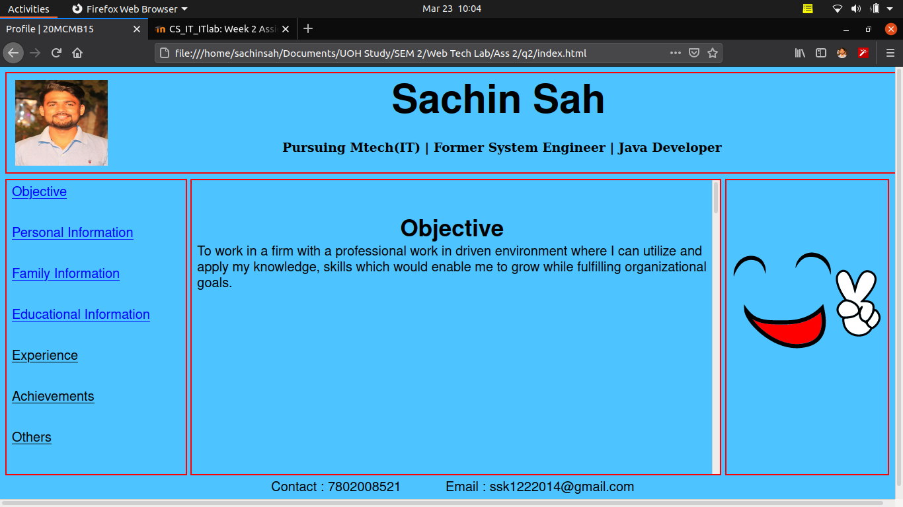
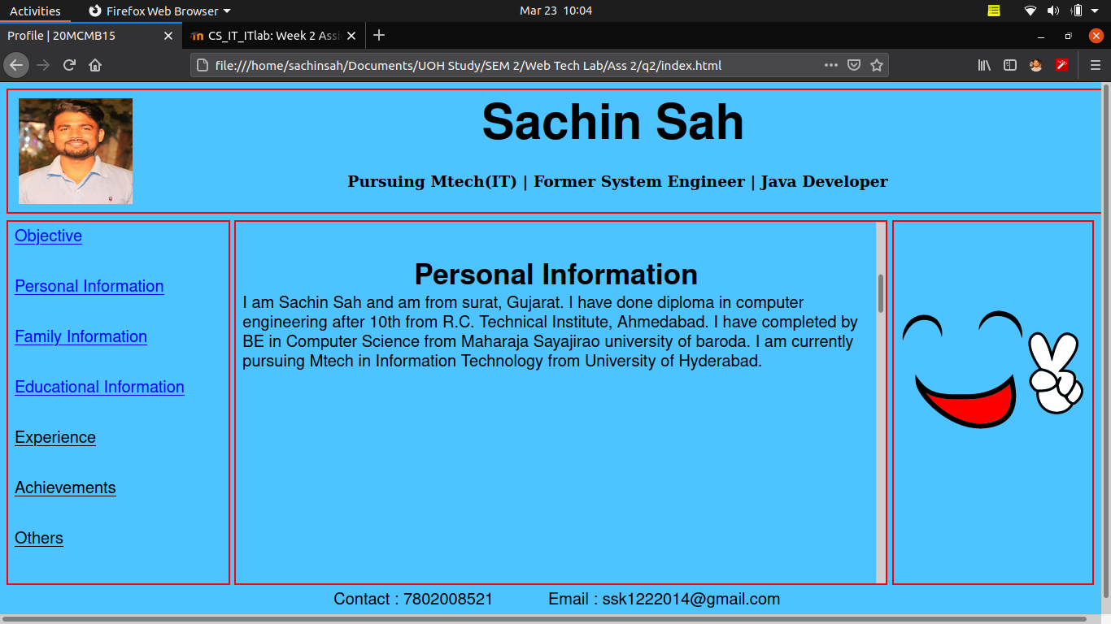
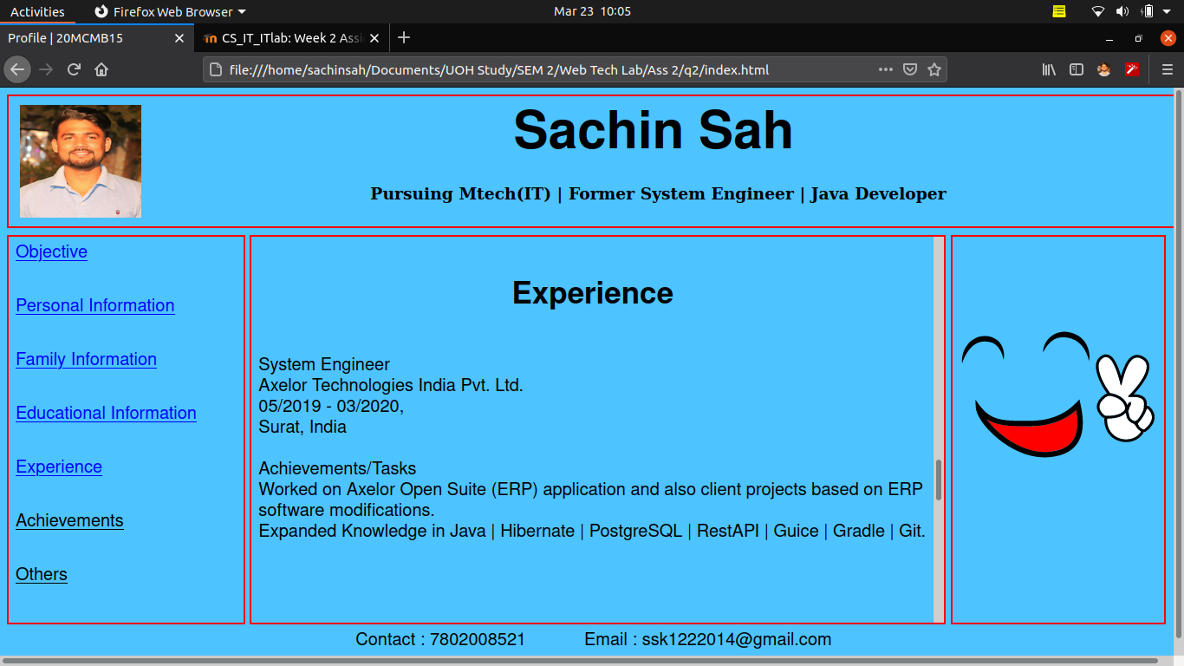

Q.3 Build a Google.com similar page.

Index.html

<!DOCTYPE html>
<html lang="en">
<head>
<meta charset="utf-8">
<meta name="viewport" content="width=device-width, initial-scale=1, shrink-to-fit=no">
<title>MyEngine.com | 20MCMB15</title>
<link rel="stylesheet" type="text/css" href="main.css">
</head>
<!-- set the body bckground color-->
<body bgcolor="#307df0">

<!-- border attribute is set to 0 to set border invisible. width set to 100% to acquire all the body width and height to required size-->
<iframe src="bar.html" width="100%" height="60" style="border: 0"></iframe>
<br><br><br><br><br><!-- br tag is used for next line -->
<center><h1 class="gradient-brand">MyEngine</h1>
<!-- class attribute is used to apply css class for style -->
<input type="text" name="search" placeholder="search here ..." class="input"><br><br>
<input type="submit" name="searchbutton" value="Search" class="button">
</center>
<center>
<!-- div tag is used for defining division or section in the html document -->
<!-- &nbsp; is used for space -->
<div>India <br>
About &nbsp;&nbsp; Advertisement &nbsp;&nbsp;Privacy &nbsp;&nbsp; Terms &nbsp;&nbsp; Setting </span></p>
</div>
</center>

</body>
</html>

bar.html

<!DOCTYPE html>
<html lang="en">
<head>
<meta charset="utf-8">
<meta name="viewport" content="width=device-width, initial-scale=1, shrink-to-fit=no">
<link rel="stylesheet" type="text/css" href="main.css">
</head>

<body>
<!-- img tag is used to add image in the page and here width and heigth is set -->
<img src="profilephoto.jpeg" width="40" height="40">
<h6>Mail | Images | SignOut</h6>
</body>
</html>

main.css

/* this class is used for myengine logo creation.
text style, size and color is set.
also background color is set. */
.gradient-brand {

font-family:"Raleway",Helvetica,sans-serif;
font-size: 80px;
margin: 10px;
width: 380px;
color: #f3ec78;
background-color: red;

}

/* float attribute is used for setting the image to right of the screen and set margin 5pixel */
img{
float: right;
margin-left: 2px;
}

/* to add style h6 tag */
h6{
font-family:"Raleway",Helvetica,sans-serif;
font-size: 20px;
margin: 10px;
font-weight: normal;
text-align: left;
color: white;
float: right;
}

/* used for setting search button style */
.button{
background-color: #1a1aff;
padding: 8px;
color: white;
border-radius: 4px;
}

/* used for search edittext box styling */
.input{
width: 50%;
}

/* used for div tag content styling */
div{
margin-top: 250px;
bottom: 5px;
font-family:"Raleway",Helvetica,sans-serif;
color: white;
}

OUTPUT :

